**Abstract [<=300 words]**

Background: 2/3 lines

Urban land use allocation is an optimization task, pivotal for modern cities. Unplanned cities such as Dhaka, capital of Bangladesh can be greatly benefitted by proper land use allocation. Due to poor infrastructure, we have seen several tragedies occur which may also be reduced by proper allocation of land use.

Methods: 5-7 lines

The problem of land use allocation is multi objective due to various stake holders involved, but can be treated as single objective by giving objectives different weights and combining them. We tried two types of approach, elitist and non-elitist. For multi-Objective elitist approach, we used NSGAII as wrapper while using different GA methods internally. Our main approaches were named Mutation +SBX NSGAII, RNS, CR+DE, CR+DES and MSBX+MO. Our single objective approach (SOA) was elitist also. For choosing candidates for mating, we used tournament selection. For non-elitist approach we tried using PSO, JADE and DE based algorithm. We also used constrained approach for non-elitist methods and constrained non constrained and weakened constrained for elitist approach.

Results: 2-3 lines. Quantitative information.

From all the approaches CR+DE with weakened constrains performed the best, which improved the compatibility by 3.04% (price by 0.17%) for the solution with best compatibility, where the best for state of the art was 0.78% (price 0.09%). Also, SOA performed good with the best solution giving 1.86% increase in compatibility. Mutation+SBX NSGAII with weakened constraints has best increase in price (3.3%).

Conclusion:2-3 lines

Using different approaches we see elitist algorithm tends to do better for our case of land use optimization. Weakening the constraints can also be helpful. SOA approaches can give competitive results also. Depending on the priorities (price or compatibility) different algorithms may be used.

In this paper, we use single and multi-objective optimization algorithms for solving land use allocation problems to find the best algorithm. The Single objective algorithm has competitive performance but the multi objective algorithm was best overall. We propose a new technique CR+DES that works best in constrained settings. The area of study is Dhanmondi residential area.

© 2017 Elsevier Inc. All rights reserved.

*Keywords:* CE+DES; Dhanmondi

**1. Introduction**

The problem of urban land use allocation is crucial in developing countries. Bangladesh being such a country has the need for good optimization algorithms. The problem is very complex as it is often multi-objective due to different stakeholders being involved with different requirements. As land shortage is common in a congested city such as Dhaka, effective land use allocation is compulsory. Also, in recent times disasters due to bad land use allocation is making life of people of Dhaka city challenging. The incident of residents getting caught by fire is becoming common because of poor planning which places residents and factories in the same building.

To solve such problems there are often conflicting objectives. The owner of a plot almost always wants to allocate a use that increases the value of the land. But the government wants to allocate a use that gives the most easement to the public. So, the objective to increase price (for owner) and to increase compatibility (for public comfort) can be conflicting. Such a situation can be an owner wanting to allocate a commercial space while the best interest for the public will be to assign residential flats to that area. There can also be more conflicting objectives.

**1.1 Literature review**

**<1/2 lines about what is coming next.**

We discussed literature review in two parts. We will talk about the land use allocation first frim the prespective of a planner. Then optimization algorithms in general.

1**.1.1. Land-use allocation**

To solve the problem of land use allocation for agricultural land Von Th¨unen’s theory[1] was proposed in 1826. Modern land use allocation theories are based on this. For urban land use allocation initially there were three models, which were the Concentric Zone Model (E.Burgess, 1920)[2], the Sector Model (H.Hoyt, 1939)[3] and the Multiple Nuclei Model (C.Harris and E.Ullman, 1945)[3,4]. The centre of attention for these models were the Central Business District and the transport routes. Bid rent function was introduced for various kinds of urban land-uses (Alonso, 1964)[5].

The way prices of plots vary with the distance of lands from central business was found out by him. Later Lowry established the Garin-Lowry model (1960) [6] Spatial patterns of service and residential developments were taken for simulation. The area of Pittsburg was chosen.

A multi-objective optimization model was proposed by Bammi, Bammi, and Paton in 1976 [7] and Bammi and Bammi in 1979 [8] by weighting some conflicting objectives simultaneously. The model was used for land-use planning. Site was Du Page County, Illinois. They tried to minimise the conflict between adjacent land-uses, costs of community facilities and several other factors. Total acreage by land-use type was computed using linear programming. 147 planning regions were chosen for their objective. Then planners allocate the use parcel-by-parcel basis. This method of optimization has shown to reduce acreage by 50 percent.

Using another method, Geographic Information System (GIS) and multi-criteria evaluation was merged by Carver (1991) [9]. This was done to find the optimum location for disposal of radioactive waste. The site was in the UK. Research on conflicting objectives for competing spaces was seen in works of Eastman, Jiang, and Toledano (1998) [10]. Finding a solution to land use allocation using trade off of conflicting use cases was done by Beinat and Nijkamp (1998) [11] and Masoomi, Mesgari, and Hamrah (2013) [12].

Multi-facility location model was developed by Church (1999) [13]. For this purpose he used the p-median model which was for green-field. Allocation of activities were new for the area. Ligmann-Zielinska, Church, and Jankowski in 2005 [14] found that, in this particular study there was absence of existing land-use patterns at initialization which was considered a limitation. The Zero-one programming model used for solving the problem of land acquisition was proposed by Williams (2002) [15]. In the model, Williams used three selection criteria. Which were spatial contiguity, total cost and total area.

Usage of GIS for finding optimal sites was proposed by Li, He, and Liu (2009) [16]. Both the total costs and total benefits were maximised for this method. All of these methods had linear constraints. And allocated one use for each land. We can see in modern times Heuristic approaches have become very common for solving land use allocation problems which can work with multiple objectives. Simulated Annealing was proposed by Semboloni in 2004 [17] for optimization of facilities in residential and commercial areas. Then PSO (particle swarm optimization) was used by Shifa et al. (2011) [18]. Maximum suitability and maximum cost (of changing land shape) was considered.

Goal Programming used for multi objective optimization was used by Cao et al. in 2012 [19]. The site was Tongzhou Newtown in Beijing, China. In 2013, Masoomi, Mesgari, and Hamrah [12] found out that non-convex optimal solutions could not be obtained by minimising linear combinations of objectives. ‘Pareto Front based methods’ is being used recently in some literature for multi objective methods. Masoomi, Mesgari, and Hamrah in 2013 [12] found out optimum arrangement of urban land-uses using Pareto Front. The site was a district in Tehran.

**1.1.2. Optimization**

Schaffer in 1985 [20] developed a vector-evaluated GA which was multi-objective. Weight-based Genetic Algorithm, Multi-Objective Evolutionary Algorithms (MOEAs) [21], Niched Pareto Genetic Algorithm [22][23], SPEA2 [24], NSGA, Fast NSGA-II [25] and several algorithms were proposed for multiple objectives. Their performances were evaluated by Fonseca and Fleming in 1993 [26]; Zitzler, Laumanns, and Thiele in 2001 [27] ; Deb et al. in 2002 [28] and others.

Combination of various GA methods is also seen (Konak, Coit, and Smith in 2006) [29]. Afsana Haquea and Yasushi Asami (2014) [30] used GA for Optimising urban land use allocation for planners and real estate developers. Nusrat Sharmin, Afsana Haque and Md. Monirul Islam in 2018 [31] used the Multi-Objective Optimization Approach using genetic algorithms for Alternative Land-use Allocation.

Another type of genetic algorithm is Differential Evolution (DE) which can move around search space in an effective way. It was first proposed by Price and Storn [32]. For improving the performance of DE proper parameter setting needs to be found out. Ali [33] showed that large scale factor (F) can slow down efficiency. Wang and Huang [34] reduced the search and applying the same method found out that increasing scale factor (F) can cause probability distribution for points generated to be uniform. Which makes mutation operators ineffective.

Zaharie [35] analysed binomial and exponential crossover operations. Brest et al. [36] proposed a new control parameters strategy, which was self-adapting, this type of DE is known as jDE. Qin et al. [37] propose a self-adaptation strategy for both control parameters and mutation. Wenchao Yi, Yong Chen, Zhi Pei, Jiansha Lu in 2022 [38] used Adaptive differential evolution with ensemble operators for continuous optimization problems**.**

**1.2 Our Contributions**

This paper makes the following key contributions:

* Establishing the importance of elitist algorithm for muti objective land use optimization setting.
* Finding out how single objective approaches can be competitive.
* Discovering how the difference vector or mutant vector can be used a an individual.
* The effects of weakening constraints and how it may help in getting better results.

**1.3 Roadmap**

The rest of the paper is organised as follows. In section 2, we present our methods, where we have discussed constraints, representation and algorithm. In Section 3 presents our results and discussion. In Section 4 we wrap up with conclusion.

**3. Methods**

**<1/2 lines to motivate the reader…>**

We will discuss about what is our objectives first. Then the constraints that the results should satisfy. After that we will talk about algorithms in two broad categories elitist and non-elitist.

**3.1 Objective Functions**

The objective was to maximise land compatibility and price. To achieve our goal, we will use optimization algorithms. For that reason, we will define the **objective functions**. Then representation and optimization algorithm.

To solve the land allocation problem, two objectives which are, compatibility and land price were taken into account. The objectives, constraints and representation were the same as the two objectives and four constraints and representation in Afsana et al. [31]. For optimization we will use the JADE algorithm [38], also traditional DE has been used. 2.1.

**Maximising compatibility between neighbouring lands**

$$maximise \sum_{i∈I}^{ }{} \sum_{i∈j(i)}^{ }{} \sum_{l=1}^{k}{} \sum_{m=1}^{k}{} r_{j}r_{i}Z_{lm}X_{im}X_{jl}$$

where, *I* = set of plots. *j(i)* = neighbourhood of plot *i*. $Z_{lm}$ = compatibility index of use *l* and *m*. $X_{lm}$ = Proportion of use *m* in plot *i*. $X_{jl}$ = proportion of use *l* in plot *j*. Here proportion of a use is the ratio of the floors needed for specific use and total number of floors. $r_{i}$ = total floor space of plot *i* and, $r_{j}$ = total floor space of plot *j*. Mutation of this kind is a feature of the JADE algorithm.

**Maximising Price of Plots**

$$Maximise\sum_{m=1}^{K}{} V_{im}X_{im}$$

where*, i* = plot number and *m* is the use. Also, $V_{im}$ = price of plot *i* for use *m*. $X_{im}$ = proportion of use *m* in plot *i*. Here we try to maximise a plot's price for every use.

**3.2 Constraints**

$\sum_{m=1}^{K}{} X_{im}=1$

$0 ≤X_{im}≤1$

$\left(1-γ\right)T_{m}^{*}≤\sum_{i=1}^{N}{} r_{i}X_{im}≤(1+γ)T_{m}^{*}$

$………≤\sum_{i=1}^{N}{} \sum_{m=1}^{K}{} V_{im}X_{im}≤ ………$

Here, γ in constraint 3 is percentage of change allowed in any type of space use and constraint 4 keeps the land price in a range.

**3.3 Optimising Algorithm**

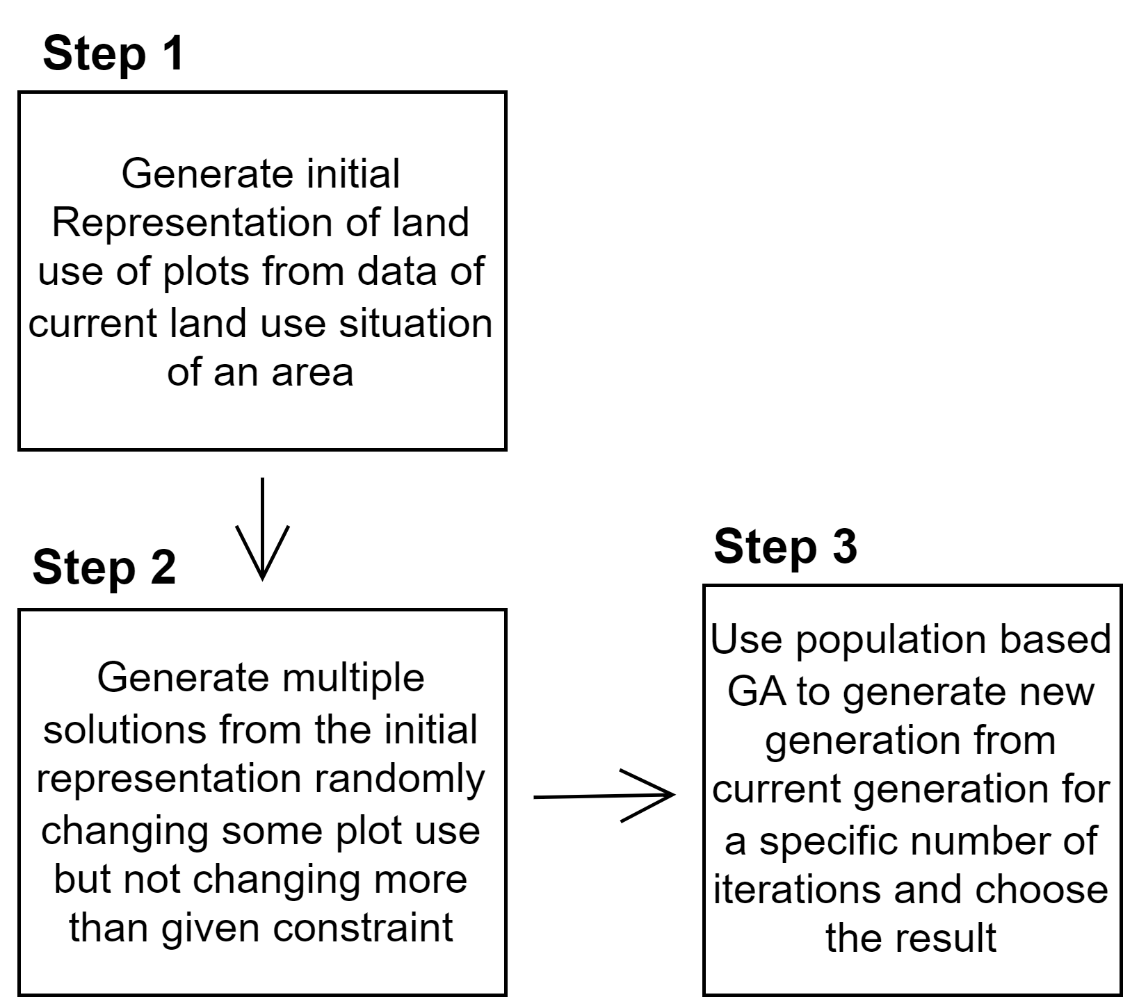

The optimisation algorithms can be divided into three steps. Step 1 and 2 are same for all the tests. Same representation was used for all runs. Also the initial population generation was the same for all runs. But step 3 was different for different cases.

**3.3.1 Representation**

We will be using meta heuristic optimization algorithms. Each Building can be thought of as a chromosome where each genome is a floor. So, a solution which constitutes many buildings will contain many chromosomes. So, the chromosome collection of a solution can also be thought of as a large chromosome.

Here each cell is a plot.

|  |  |  |  |  |  |  |  |  |  |
| --- | --- | --- | --- | --- | --- | --- | --- | --- | --- |
| *1* | *2* | *3* | *4* | …… | …… | …… | …… | *m-1* | *m* |

So, the chromosome of the representation will be a representation of the area and the gene will be a certain plot. The entry will be the representation of a building. As each building has multiple floors the representation of the floors will be a number $m_{1}m_{2}…..m_{n}$. Where *n* is the number of highest possible floors a building can have. We gave residential flat= 0, commercial = 1 and office = 2. So each entry of the gene will be an integer number (0000 if all floors are residential, 0011 if two are residential and 2 are commercial and so on). This number will be ternary as there are three possible numbers.

**3.3.2 Generating Initial Population**

For initial representation 100 initial solutions (representations) were generated. For 30% of plots of each representation the land use was changed.

**3.3.3 Genetic Algorithms**

The approaches can be divided into two categories. Elitist approach and weak parent replacement approach.

***Selection***

Selection for crossover is done using tournament selection.

***Mutation (before or in place of crossover)***

We do mutation before crossover for some cases. Also, instead of doing crossover every time, we choose only mutation sometimes with a probability. Depending on the algorithm of our choosing the probability of mutation may be more or less.

***Crossover***

We apply SBX or uniform crossover.

After adding the new solution to population, we choose elitist or weak parent replacement approach

**3.3.3.1 Elitist Approach**

Most of the experimental runs were done using an elitist approach. The elitist algorithm for SOA was sorting depending on fitness value by using a weighting equation. But for other multi objective cases the approach was to use non dominated sorting and choosing the best solutions.

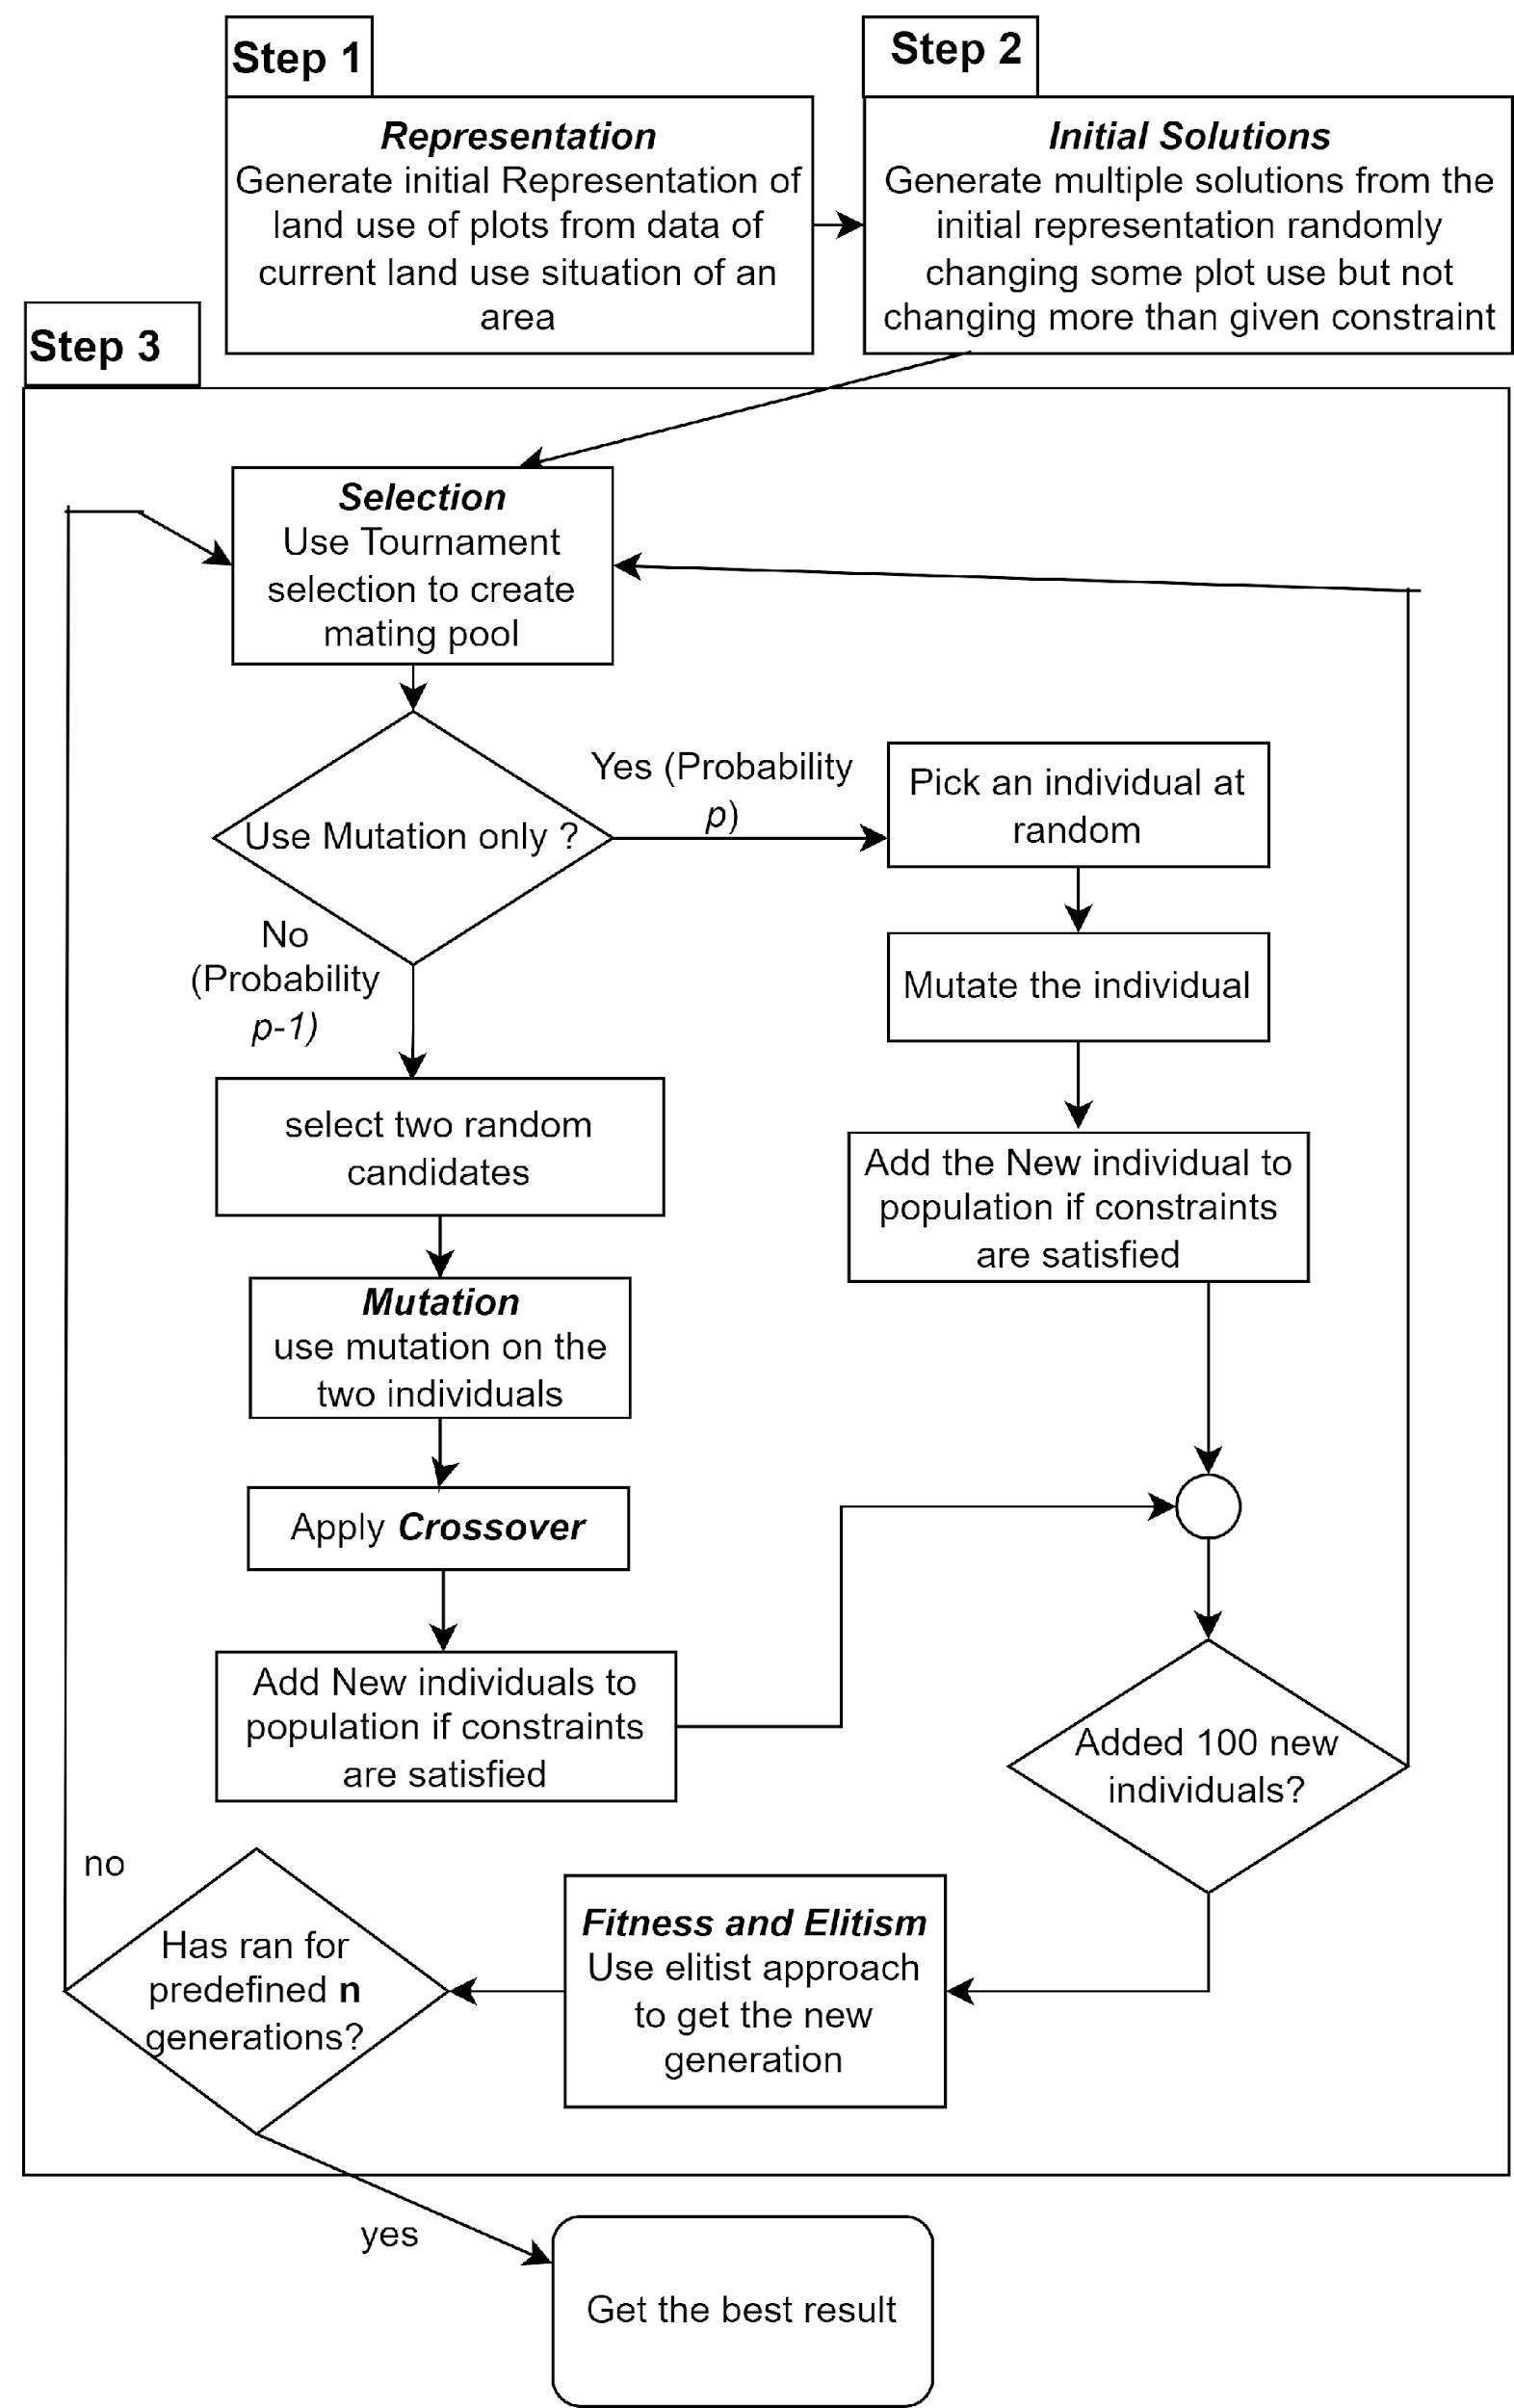

**Table: Descriptions of elitist algorithms used**

|  |  |  |  |  |
| --- | --- | --- | --- | --- |
| **Algorithm** | **Mutation before crossover** | **crossover** | **Mutation or other approach (*In place of crossover*)** | **Fitness for elitism** |
| SOA | $$X_{i1}=X_{i }*C_{1}$$ | SBX | $$X_{i1}=X_{i }*C_{1}$$ | *a*price + b*compatibility* |
| PM+NS | … | … | Polynomial mutation | Pareto Rank |
| RMNS | … | … | Polynomial or random mutation | Pareto Rank |
| RNS | … | … | Random Mutation (floor wise) | Pareto rank |
| **CR+DES** | **…** | **Uniform crossover** | **Difference vector used in DE is used as the candidate solution. This was done in place of crossover with a probability** | **Pareto rank** |
| **CR+DE** | **…** | **Uniform crossover** | **DE mutant is used as candidate solution** | **Pareto rank** |
| UCR-NS | … | Uniform crossover (floor wise) | Polynomial mutation | Pareto rank |
| PMO NS | … | … | Polynomial mutation | Pareto rank |
| MSBX-MO | $$X_{i1}=X_{i }*C_{1}$$ | SBX | … | Pareto rank |

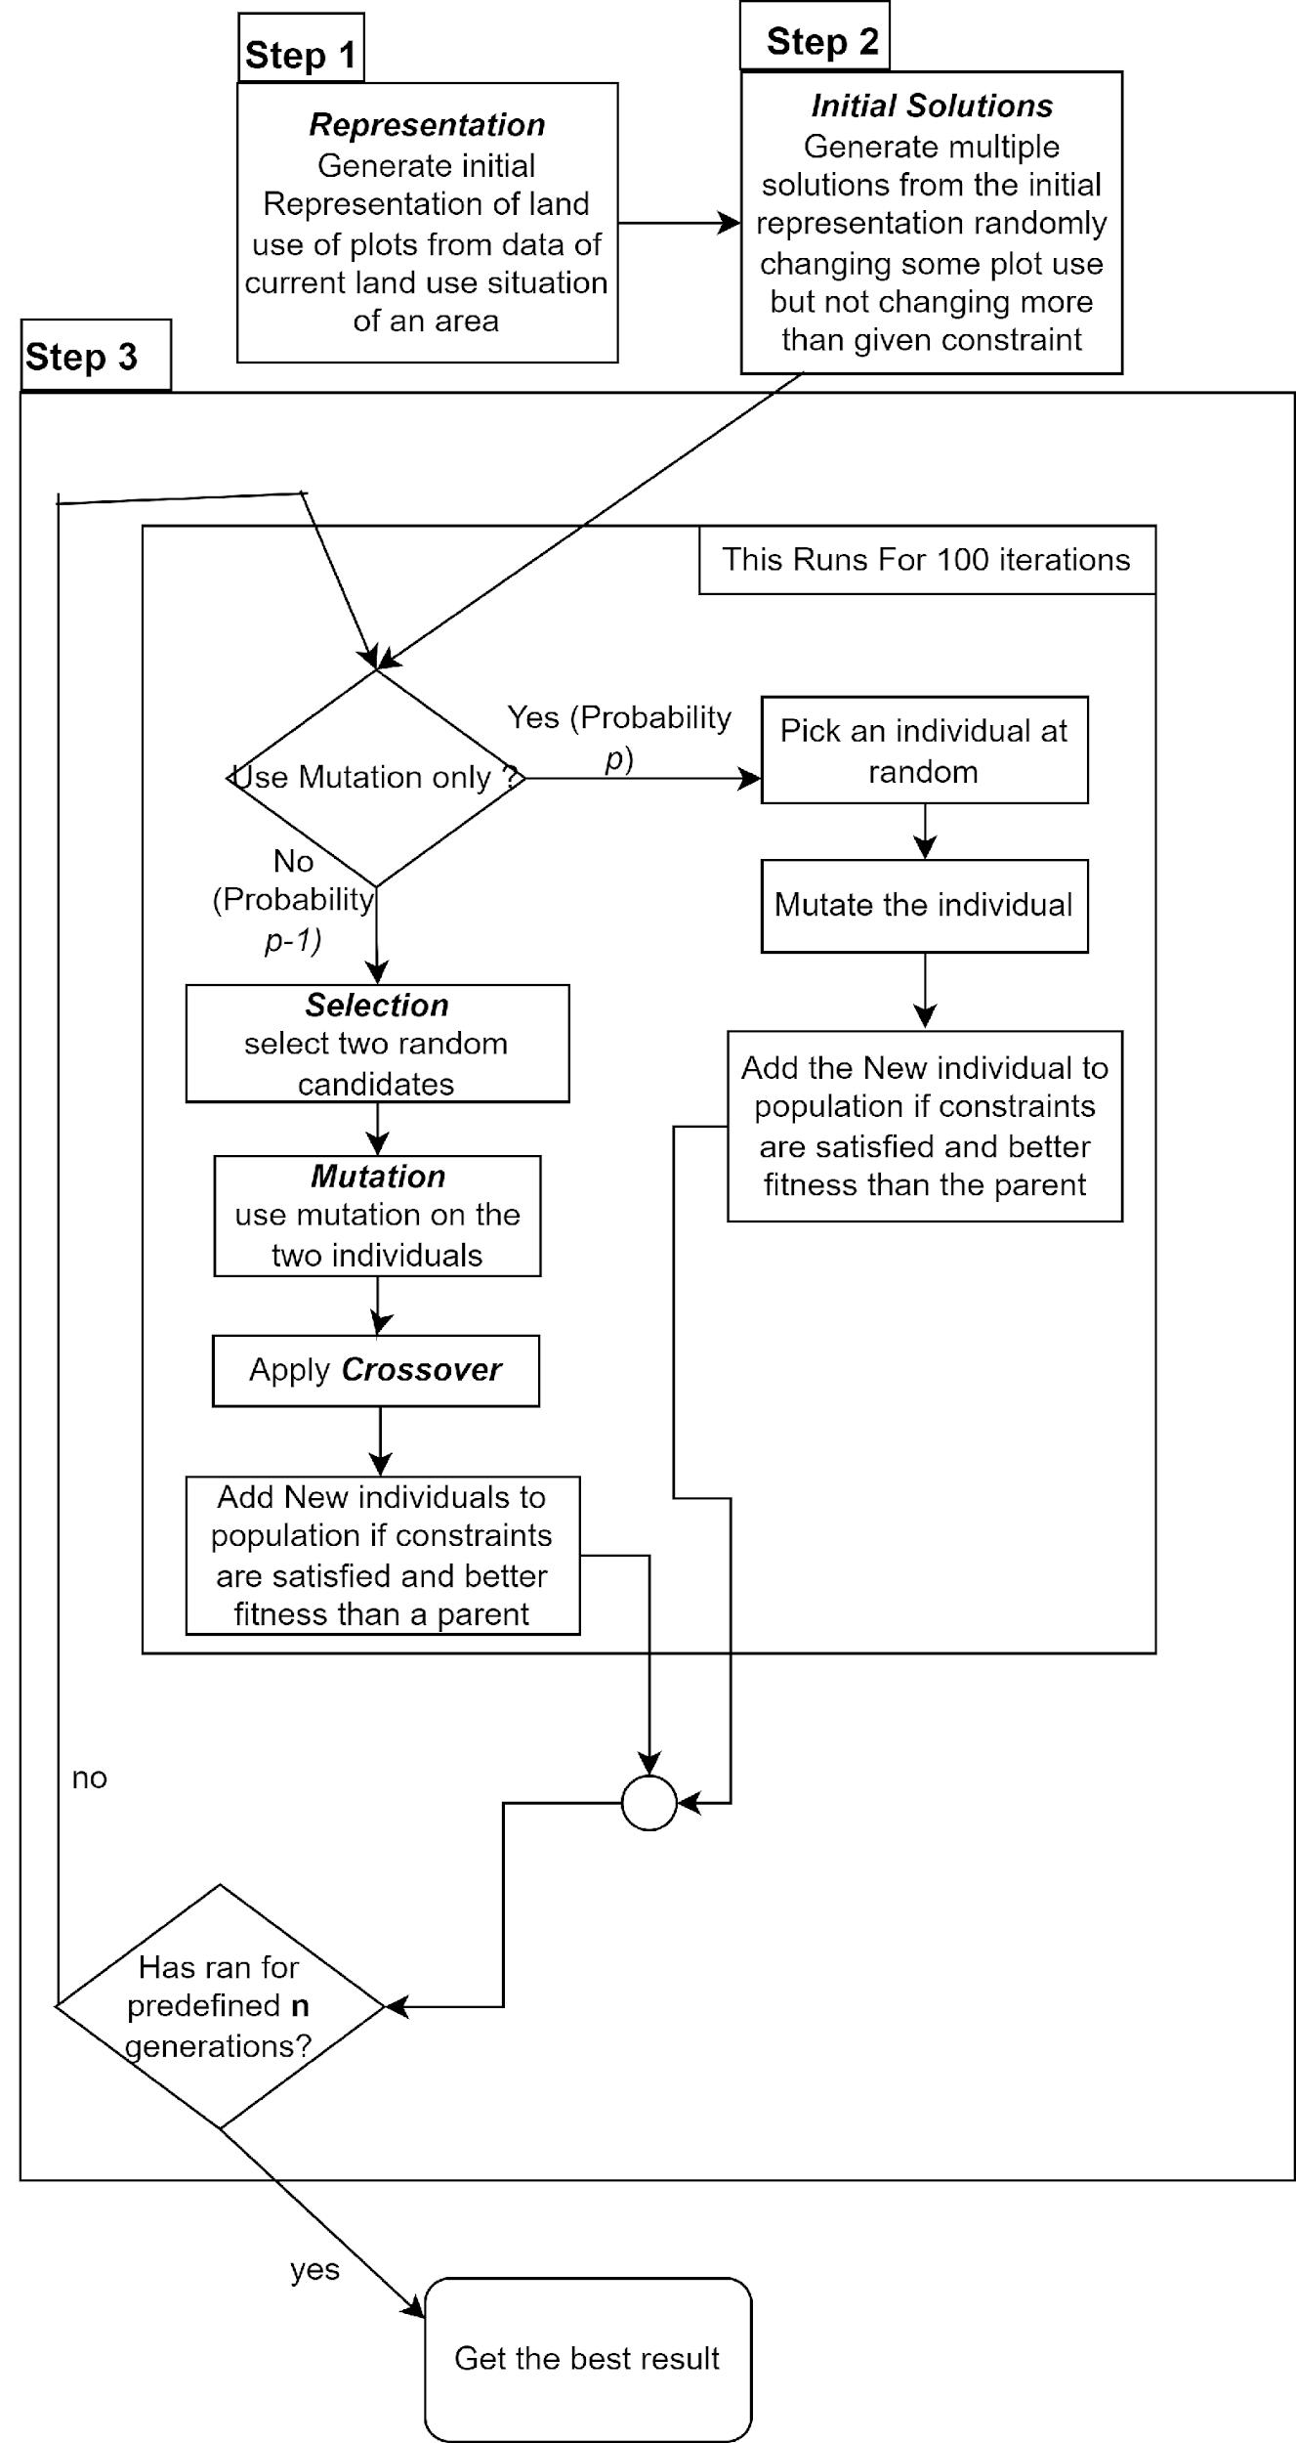

**Table: Descriptions of WPR algorithms used**

|  |  |  |  |  |
| --- | --- | --- | --- | --- |
| **Algorithm** | **Mutation before crossover** | **crossover** | **Mutation or other approach (*In place of crossover*)** | **Fitness** |
| DEP-MO | $$X_{i1}=X_{i }+\left(X_{random1}-X_{random2}\right)*C+\left(X_{pbest}-X_{i}\right)*C_{1}$$ | SBX | … | Pareto rank |
| DEVP-MO | $$X_{i1}=X_{i }+\left(X_{random1}-X_{random2}\right)*F+\left(X_{pbest}-X_{i}\right)*F$$ | SBX | $$…$$ | Pareto rank |
| DEMO | $$X_{i1}=X_{i }+\left(X_{random1}-X_{random2}\right)*C$$ | SBX | … | Pareto rank |
| MSBX+MO | $$X_{i1}=X_{i}+X_{random}*C$$ | SBX | … | Pareto rank |
| PSO+NS | 1. $X_{informant }=tournament_selection(best 50 individuals)$ 2. $X_{augment}=a+b*\left(X_{informant}-X_{i} \right)+c*\left(X_{best}-X_{i}\right)+d*(X_{personalBestOf(i)}-X_{i})$ 3. $X_{i_new}= X_{i}+X_{augment}*e$ | … | … | Pareto rank |
| JADE | *1. F = Cauchy(location, scale)*  2. $X_{i1}=X_{i }+\left(X_{random1}-X_{random2}\right)*F+\left(X_{pbest}-X_{i}\right)*F_{ }$ | SBX | … | Pareto rank |

Notes: *pbest* is a random individual selected from top *p%* individuals. In all cases other than PSO+NS, $X_{i1} , X_{i }$ are crossed over. $X_{i }$ is the current individual the optimization algorithm is working with. $X_{personalBestOf(i)}$ is the best location for current solution $X_{i }$. a, b, c, d, e, $C_{1}$, C are all constant values. $X_{random1}, X_{random2}$, $X_{random}$ are random individuals selected from the population.

**4. Results and Discussions**

|  |
| --- |
| **Comparison of results of different algorithms** |
|  |
|  |
| **Fig1**: In the figure we see 15 runs that we did for the land use optimization. For some algorithms several runs were tested. X-asis has land price, and Y-axis is the compatibility. The pareto front of each algorithm at 150th iteration is plotted*. (Due to overlapping some pareto front got hidden completely).* SOA which returns only one value has the highest compatibility. MSBX+MO methods give high prices. They got a very high price for land also keeping a good compatibility value. CR+DES performed the overall best. |

For different approaches different results are seen. CR+DES gives the best pareto front for compatibility. We will call these results **initial results**. From these results the best price belongs to MSBX+MO at the 150th iteration. Also, CR+DES has the best compatibility.

|  |
| --- |
| **Results of DE based and PSO algorithms** |
|  |
|  |
| Fig3: PSO performed the worst. Also, differential evolution approaches converged to a point. The grey points in the graph is the point where DE methods converge. |

**SOA Analysis**

|  |  |
| --- | --- |
| **SOA Prices for Different Coefficient Values** | **SOA Compatibility for Different Coefficient Values** |
|  |  |
| . |  |
| Fig: Having different coefficient value for, *Fitness* = *a*compatibility + b* price* gives various price values. The best values are observed for a=22.5, and b=1 (before normalisation). Which is the ratio observed for compatibility/price in most of the previous results. This value of coefficient is used in all SOA tests, when we compared SOA with other approaches | Fig: Having different coefficient value for, *Fitness* = *a*compatibility + b* price* gives various compatibility values. The best values are observed for a=22.5, and b=1 (before normalisation). Which is the ratio observed for compatibility/price in most of the previous results. This value of coefficient is used in all SOA tests, when we compared SOA with other approaches |

Running SOA for different coefficient values we are able to find a coefficient value that gives significantly better values than other coefficient values. And this value is the ratio of compatibility and price found in other approaches.

**Analysis With only price lower limit constraint**

|  |
| --- |
| **Results with no constraints on upper limit of price and land use change (constraints remain on lower limit of price, results for 150th iteration)** |
| 1. **(b)**     **(c) (d)**  **(e) (f)**    **(g) (h)** |
|  |
| Fig 4: Here the figures have pareto front or best individual (for SOA) at 150th iteration. In the optimization algorithm individuals that didn’t satisfy upper limit of price or land use change constrained were accepted. At 150th no individual remained where constraints were satisfied. For figures (a)-(g) we have non constrained results with best results found in the tests. One of the individuals for Constrained and unconstrained versions of the algorithms are pointed. For Mutation+SBX NSGAII (a), SOA (b) and CR+DE (f), the results are converging to a location. But for RNS (c), RMNS (d), MSBX+MO (e) and CR+DES (g) the results are spread out. From (h), a comparison between non-constrained versions, the results that were converging, gave better fitness. But they were unable to dominate CR+DES. The best result was from mutation + SBX NSGAll. For RNS, RMNS and MSBX+MO the results, for a slight increase in price, gave much worse compatibility. If no constraints are given we can say Mutation+SBX NSGAII gives best results. |

**Analysis with weakening land use constraint and allowing 100% plots to be changes by genetic algorithm**

This approach caused algorithms to get stuck in local minima. No results were being generated that satisfied initial constraints. This approach was tested for CR+DE, CR+DES, SOA,

**Analysis with weakening land use constraint and keeping price constraint**

Results were generated by weakening only land use change constraints. Change allowed from the genetic algorithm was 20% from initial in all cases. We use notation *p% LC* for pointing individuals to these approaches.

|  |  |
| --- | --- |
| **Mutation+SBX NSGAII using weaker constraints (150th iteration)** | **Mutation+SBX NSGAII 100% LC and initial results (150th iteration)** |
|  |  |
|  |  |
| Fig: The individuals of pareto front of different runs are shown. For each run different values of constraints are used. The price limit constraint was kept unchanged. For land use 40% , 60% , 80% and 100% changes were allowed for different cases. As the constraint became weaker the results were better. Only individuals that satisfy the initial 30% percent change were allowed. So even though the values of constraints were weaker, there were many results that satisfied initial harder constraints. So for Mutation+NSGAII, weakening the constraint gives better results. | Fig: The value of individuals of 100% constraint limit are compared with best constrained results. The results of Mutation+ SBX NSGAII were better than results with harder constraints. |

|  |  |
| --- | --- |
| **RNS using weaker constraints (150th iteration)** | **RNS 100% LC and initial results (150th iteration)** |
|  |  |
|  |  |
| Fig: For RNS, weakening the land use change constraint initially does not improve or reduce fitness. But 100% land use change gives some results with much better price but worse compatibility along with results similar to harder constraints. | Fig: The results for 100% land use change allowed values have worse values than MSBX+MO. The individual got by using MSBX+MO pareto dominates the solutions of RNS 100% LC, which gave better prices. Also most other solutions are pareto dominated. |

|  |  |
| --- | --- |
| **RMNS using weaker constraints (150th iteration)** | **RMNS 100% LC and initial results (150th iteration)** |
|  |  |
|  |  |
| Fig: For RMNS, weakening the land use change constraint initially does not improve or reduce fitness. But 100% land use change gives some results with much better price but worse compatibility along with results similar to harder constraints. So RMNS with weakened constraints behave similarly to RNS with weakened constraints. | Fig: The results for 100% land use change allowed values have worse values than MSBX+MO. The individual got by using MSBX+MO pareto dominates the solutions of RMNS 100% LC, which gave better prices. Also most other solutions are pareto dominated. So results are similar To RNS LC. |

|  |  |
| --- | --- |
| **CR+DES 100% LC and initial results (150th iteration)** | **CR+DE 100% LC and initial results (150th iteration)** |
|  |  |
|  |  |
| Fig: For CR+DES 40% LC performed better than other approaches and had the best compatibility. It performed better than the CR+DES approach. Even though the price of MSBX+MO , the overall performance was best. | Fig: The performance of CR+DE 40% LC didn’t improve than CR+DE. Weakening the constraints has no effects. |

Using the p% LC approach, the best improvement is observed for SBX+NSGAII.

**Analysis with weaker land use constraint and allowing change in genetic algorithm**

The land use constraint was slightly weaker (40%). Also the genetic algorithm was allowed to change 20% of plots in each iteration, instead of allowing 20% from initial solution. The prevented generation of too many invalid (constraint unsatisfying) results, while giving proper amount of flexibility. (*Notation* *P% COA (constraints on area) will be used to mean these approaches.)*

|  |  |
| --- | --- |
| **Mutation+SBX NSGAII 40% COA and Mutation+SBX NSGAII initial results (150th iteration)** | **Mutation+SBX NSGAII 40% COA and initial results (150th iteration)** |
|  |  |
|  |  |
| Fig: Having slight weaker land use constraints didn’t improve the results much for Mutation+ SBX NSGAII. The results had individuals with better price but worse compatibility. | Fig: When compared with other approaches, Mutation+SBX NSGAII 40% LC, performs worse than CR+DES. Also half of the individuals of this approach are pareto dominated by MSBC+MO and other half is pareto dominated by Mutation +SBX NSGAII. |

|  |  |
| --- | --- |
| **SOA 40% COA and SOA initial results (150th iteration)** | **SOA 40% COA and initial results (150th iteration)** |
|  |  |
|  |  |
| Fig: SOA 40% COA, has better compatibility but worse price. | Fig: Individuals in SOA 40% COA are dominated mostly by individuals CR+DES (price wise or compatibility wise) |

|  |  |
| --- | --- |
| **RNS 40% COA and RNS initial results (150th iteration)** | **RNS 40% COA and initial results (150th iteration)** |
|  |  |
|  |  |
| Fig: RNS 40% COA, performs worse than initial approach, as most of the individuals are pareto dominated by RNS. | Fig: Individuals in RNS 40% are dominated mostly by individuals by Mutation+SBX NSGAII, also totally dominated by MSBX+MO making not the best approach in any case (price wise or compatibility wise) |

|  |  |
| --- | --- |
| **RMNS 40% COA and RNS initial results (150th iteration)** | **RMNS 40% COA and initial results (150th iteration)** |
|  |  |
|  |  |
| Fig: RMNS 40% COA, performs worse than initial approach. | Fig: Individuals in RMNS 40% are dominated mostly by individuals by Mutation+SBX NSGAII, also totally dominated by MSBX+MO making not the best approach in any case (price wise or compatibility wise) |

|  |  |
| --- | --- |
| **CR+DES 40% COA and CR+DES initial results (150th iteration)** | **CR+DES 40% COA and initial results (150th iteration)** |
|  |  |
|  |  |
| Fig: For CR+DES 40% LC, the individuals performed better than CR+DES. Weakening constraints has caused improvement in results. | Fig: The pareto front of CR+DES 40% COA had better individuals than most other pareto front. Only MSBX+MO had pareto front with much better prices, but with worse compatibility than most individuals of CR+DES 40% COA. |

|  |  |
| --- | --- |
| **CR+DE 40% COA and CR+DE initial results (150th iteration)** | **CR+DE 40% COA and initial results (150th iteration)** |
|  |  |
|  |  |
| Fig: CR+DE 40% COA had individuals in pareto front, which has much better prices but worse compatibility. The individuals dominate a portion of the pareto front of DR+DE which has worse prices. | Fig: Compared to initial approaches CR+DE 40% doesn't perform better as all of the individuals of this pareto front are dominated by individuals in pareto front MSBX+MO approach. |

Using *p% COA* approach gives us worse results for RNS, RMNS and CR+DE as all the individuals in the pareto front are dominated by individuals of the pareto front of MSBX+MO approach. But the Mutation +SBX NSGA II COA approach gave competitive results. CR+DES P% COA approach gave the best results.

|  |
| --- |
| **Comparison with state of the art** |
|  |
|  |
| Fig3: Comparing with the state-of-the art approach SBX NSGAII (2018)[31], most of the elitist algorithms used performed much better. Price wise Mutation+SBX NSGAII performed best. All of the individuals except one at 150th iteration dominated all the individuals from SBX+NSGAII. CR+DES, CR+DES 40% LC and CR+DES 40% COA has much better compatibility. PSO+NS performed the worst, JADE, DEMO, DEP+MO performed worse and converged to a price and compatibility. |

**Comparison of best results**

We can categorise the final solution as Type – I,II and III. Type-I : Solution With the best Compatibility. Type-II : Solution with best Land Price. Type-III :Solution with highest Crowding distance.

Comparison

Initially, price: 132,186,906,096.6 TK and Compatibility: 3,330,225,944,839

Table I **Comparison of best results**

|  |  |  |  |  |  |  |
| --- | --- | --- | --- | --- | --- | --- |
| Approach | Type I  Compatibility | Type I  Price | Type II  Compatibility | Type II  Price | Type III  Compatibility | Type III  Price |
| SBX NSGAII [31] | 3356150300205.49  (0.78%) | 132305756706.091  (0.09%) | 3232183983366.45  (-2.9%) | 133227749575.418  (0.79%) | 3277425105061.65  (-1.58%) | 132816985060.582  (0.48%) |
| Mutation+SBX NSGAII | 3384601692281.49  (1.63%) | 133064111963.254  (0.66%) | 3345052766036.75  (0.445%) | 133813107991.975  (1.23%) | 3362832189181.03  (0.98%) | 133751002770.043  (1.18%) |
| RMNS | 3372079168187.39  (1.26%) | 132830874484.466  (0.49%) | 3302427639401.81  (-0.83%) | 133540406643.782  (1.024%) | 3321366377650.63  (-0.266%) | **133515235391.846**  **(1.005%)** |
| SMO-NS | 3343986072222.05  (1.005%) | 132173989645.649  (-0.01%) | 3224075997318.59  (-3.19%) | 133324540963.817  (0.861%) | 3274633991138.64  (-1.67%) | 133127311369.718  (0.71%) |
| RMCN | 3366067260490.77  (1.076%) | 132676512741.997  (0.37%) | 3318219857564.81  (-0.36%) | 133393392011.227  (0.91%) | 3334607368759.17  (0.13%) | 133222004641.809  (0.78%) |
| RNS | 3380302318180.21  (1.5%) | 133151206423.996  (0.73%) | 3318421740788.17  (-0.35%) | 133834519717.96  (1.25%) | 3368280067582.77  (1.14%) | 133364579278.747  (0.89%) |
| MSBX+MO* | 3354195294493.69  (0.72%) | **135039397693.526**  **(2.16%)** | **3353102034373.41**  **(0.69%)** | **135863560805.355**  **(2.78%)** | ………….. | …………. |
| SOA* | 3392272517485.75  (1.86%) | 132926813328.186  (0.56%) | ………… | ………….. | …………. | ………… |
| CR+DE | 3381977452715.09 | 132504395049.385 | 3222787734423.59 | 133212844190.279 | 3308635639523.25 | 133183405081.487 |
| CR+DES | 3423993548263.17 | 132085992820.068 | 3273710675977.46 | 133697909076.343 | 3344381518514.85 | 133497733764.73 |
| CR+DES 40% COA | **3431732936360.97**  **(3.04%)** | 132414416717.383 | 3327948461208.41 | 134434739314.772 | **3411497970762.37** | 133435022802.364 |
|  |  |  |  |  |  |  |

Note: For SOA we have only one result, there is no pareto front. We call the only result type 1 result. For MSBX+MO we only got type 1 and 2 results for our run. There was only two results in the pareto front

From Table 1 we see the CR+DES 40% COA gives the best results. It gives the highest Compatibility with competitive prices. MSBX+MO still gives the best prices but CR+DES 40% COA performs overall best.

**Ablation Study:**

**SOA, even** though much simpler than NSGA-II, performed better in terms of compatibility than most other approaches. 1.86% increase in compatibility is seen. Price was increased also.

**MSBX+MO** methodsused mutation before crossing and didn't do only mutation. So it is simpler. But it gave the best prices. Also the type II result of MSBX+MO was better than All other approaches. Price was increased 2.78% than the state of the Art, but compatibility was maintained. It also increased than state of the art, which is a 0,69% increase.

The approach

**Mutation+SBX NSGAII** gave good results. The pareto front was well defined. So, applying mutation before SBX crossover gives us great results.

**5. Conclusion**

Using several optimization procedures, it can be seen that the method of using difference vectors directly with scaling (CR+DES) gives the best result. It gives even better results using weaker constraints .DE or PSO methodologies does not give better results but SOA gives good results.

**6. References**

[1] Dauphiné A. Theoretical Geolocation Models. Geographical Models with Mathematica 2017:129–35. https://doi.org/10.1016/B978-1-78548-225-0.50007-5.

[2] Reiffenstein T. Concentric Zone Theory. The Wiley-Blackwell Encyclopedia of Social Theory 2017:1–2. https://doi.org/10.1002/9781118430873.EST0440.

[3] Schwirian K. Ecological Models of Urban Form: Concentric Zone Model, the Sector Model, and the Multiple Nuclei Model. The Blackwell Encyclopedia of Sociology 2007. https://doi.org/10.1002/9781405165518.WBEOSE004.

[4] Harris CD, Ullman EL. The nature of cities. Ann Am Acad Pol Soc Sci 1945;242:7–17. https://doi.org/10.1177/000271624524200103.

[5] Kirwan R. Book Review: Location and Land Use : Toward a General Theory of Land Rent by William Alonso; Harvard University Press: Oxford University Press, London, 1964, pp. 201, 44/-. Urban Studies 1966;3:171–3. https://doi.org/10.1080/00420986620080371.

[6] Fotheringham AS, Webber MJ. Explanation, Prediction and Planning: The Lowry Model. Econ Geogr 1985;61:106. https://doi.org/10.2307/143686.

[7] Bammi D, Bammi D, Paton R. Urban Planning to Minimize Environmental Impact. Environment and Planning A: Economy and Space 1976;8:245–59. https://doi.org/10.1068/a080245.

[8] Bammi D, Bammi D. Development of a Comprehensive Land Use Plan by Means of a Multiple Objective Mathematical Programming Model. Interfaces (Providence) 1979;9:50–63.

[9] CARVER SJ. Integrating multi-criteria evaluation with geographical information systems. International Journal of Geographical Information Systems 1991;5:321–39. https://doi.org/10.1080/02693799108927858.

[10] Eastman JR, Jiang H, Toledano J. Multi-criteria and multi-objective decision making for land allocation using GIS. Multicriteria Analysis for Land-Use Management, Springer Netherlands; 1998, p. 227–51. https://doi.org/10.1007/978-94-015-9058-7_13.

[11] Beinat E, Nijkamp P, editors. Multicriteria Analysis for Land-Use Management. Kluwer Academic Publishers; 1998.

[12] Masoomi Z, Mesgari MS, Hamrah M. Allocation of urban land uses by Multi-Objective Particle Swarm Optimization algorithm. International Journal of Geographical Information Science 2013;27:542–66. https://doi.org/10.1080/13658816.2012.698016.

[13] Church RL. Location modelling and GIS. Geographical Information Systems 1999;1:293–303.

[14] Ligmann-Zielinska A, Church R, Jankowski P. Sustainable urban land use allocation with spatial optimization. 8th ica workshop on generalisation and multiple representation, 2005, p. 1–18.

[15] Williams JC. A zero-one programming model for contiguous land acquisition. Geogr Anal 2002;34:330–49.

[16] Li X, He J, Liu X. Intelligent GIS for solving high-dimensional site selection problems using ant colony optimization techniques. International Journal of Geographical Information Science 2009;23:399–416.

[17] Semboloni F. Optimization and control of the urban spatial dynamics. Complexus 2004;2:204–16.

[18] Ma S, He J, Liu F, Yu Y. Land-use spatial optimization based on PSO algorithm. Geo-Spatial Information Science 2011;14:54–61.

[19] Cao K, Huang B, Wang S, Lin H. Sustainable land use optimization using Boundary-based Fast Genetic Algorithm. Comput Environ Urban Syst 2012;36:257–69.

[20] Schaffer JD. Some experiments in machine learning using vector evaluated genetic algorithms. 1985.

[21] Mauledoux M, Mej\’\ia-Ruda E, Caldas OI. Multiobjective evolutionary algorithms moea to solve task allocation problems in multiagent systems for dc microgrid. Applied Mechanics and Materials, vol. 700, 2015, p. 24–7.

[22] Horn J, Nafpliotis N, Goldberg DE. A niched Pareto genetic algorithm for multiobjective optimization. Proceedings of the first IEEE conference on evolutionary computation. IEEE world congress on computational intelligence, 1994, p. 82–7.

[23] rey Horn J, Nafpliotis N, Goldberg DE. Multiobjective optimization using the niched pareto genetic algorithm. IlliGAL Report 1993;93005:61801–2296.

[24] Sheng W, Liu Y, Meng X, Zhang T. An Improved Strength Pareto Evolutionary Algorithm 2 with application to the optimization of distributed generations. Computers & Mathematics with Applications 2012;64:944–55.

[25] Deb K, Agrawal S, Pratap A, Meyarivan T. A fast elitist non-dominated sorting genetic algorithm for multi-objective optimization: NSGA-II. International conference on parallel problem solving from nature, 2000, p. 849–58.

[26] Fonseca CM, Fleming PJ. Multiobjective genetic algorithms. IEE colloquium on genetic algorithms for control systems engineering, 1993, p. 1–6.

[27] Deb K, Thiele L, Laumanns M, Zitzler E. Scalable multi-objective optimization test problems. Proceedings of the 2002 Congress on Evolutionary Computation. CEC’02 (Cat. No. 02TH8600), vol. 1, 2002, p. 825–30.

[28] Laumanns M, Thiele L, Deb K, Zitzler E. Combining convergence and diversity in evolutionary multiobjective optimization. Evol Comput 2002;10:263–82.

[29] Konak A, Coit DW, Smith AE. Multi-objective optimization using genetic algorithms: A tutorial. Reliab Eng Syst Saf 2006;91:992–1007.

[30] Haque A, Asami Y. Optimizing urban land use allocation for planners and real estate developers. Comput Environ Urban Syst 2014;46:57–69. https://doi.org/10.1016/j.compenvurbsys.2014.04.004.

[31] Sharmin N, Haque A, Islam MM. Generating Alternative Land-use Allocation for Mixed Use Areas: Multi-Objective Optimization Approach. Geogr Anal 2019;51:448–74.

[32] Storn R, Price K. Differential evolution–a simple and efficient heuristic for global optimization over continuous spaces. Journal of Global Optimization 1997;11:341–59.

[33] Ali MM. Differential evolution with preferential crossover. Eur J Oper Res 2007;181:1137–47. https://doi.org/10.1016/j.ejor.2005.06.077.

[34] Wang L, Huang F. Parameter analysis based on stochastic model for differential evolution algorithm. Appl Math Comput 2010;217:3263–73. https://doi.org/10.1016/j.amc.2010.08.060.

[35] Zaharie D. Influence of crossover on the behavior of Differential Evolution Algorithms. Appl Soft Comput 2009;9:1126–38. https://doi.org/10.1016/j.asoc.2009.02.012.

[36] Pan Q-K, Suganthan PN, Wang L, Gao L, Mallipeddi R. A differential evolution algorithm with self-adapting strategy and control parameters. Comput Oper Res 2011;38:394–408. https://doi.org/10.1016/j.cor.2010.06.007.

[37] Qin AK, Huang VL, Suganthan PN. Differential Evolution Algorithm With Strategy Adaptation for Global Numerical Optimization. IEEE Transactions on Evolutionary Computation 2009;13:398–417. https://doi.org/10.1109/tevc.2008.927706.

[38] Yi W, Chen Y, Pei Z, Lu J. Adaptive differential evolution with ensembling operators for continuous optimization problems. Swarm Evol Comput 2022;69:100994. https://doi.org/10.1016/j.swevo.2021.100994.